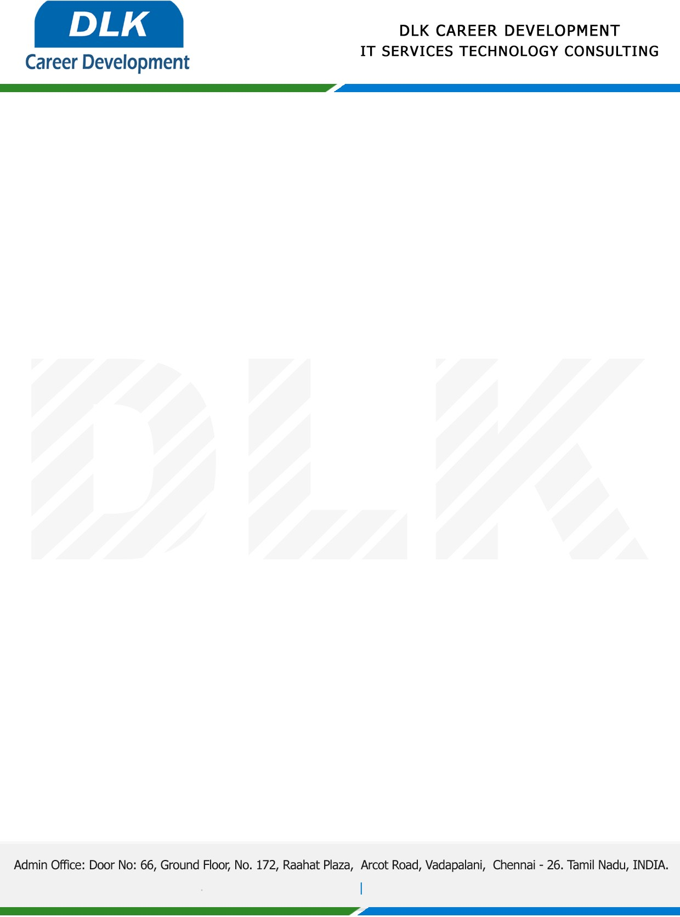

Date: 10 / December / 2022

**To**

Department of MCA -Computer Science,

Head of Department,

Dr MGR Educational and Research Institute Maduravoyal Chennai- 600095.

**Sub: Letter of Project Acceptance**

This is to certify that **MR MAHADEVAN M (REG NO:** **21304228)** that second year student of has accepted the Project Work duration from **12th December 2022** to **05th March 2023** under the domain **“Java”.** During the project, all information and data collected from you should be kept confidential.

**Topic:** An Efficient Search Method Using Features to Match Joint Keywords on Encrypted Cloud Data

We appreciate your interest in **DLK CAREER DEVELOPMENT**

